CIE-2 LAB RECORD

LAB PROGRAM NOS: 6-10

LAB INSTRUCTOR: Nandini Vineeth Madam

COURSE NAME: Object Oriented Java Programming

COURSE CODE: 19CS3PCOOJ

NAME: Kizhakel Sharat Prasad

USN: 1BM19CS074

SEM: 3RD

LAB PROGRAMS(6-10):

6) 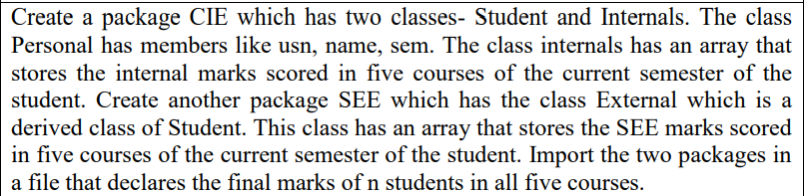

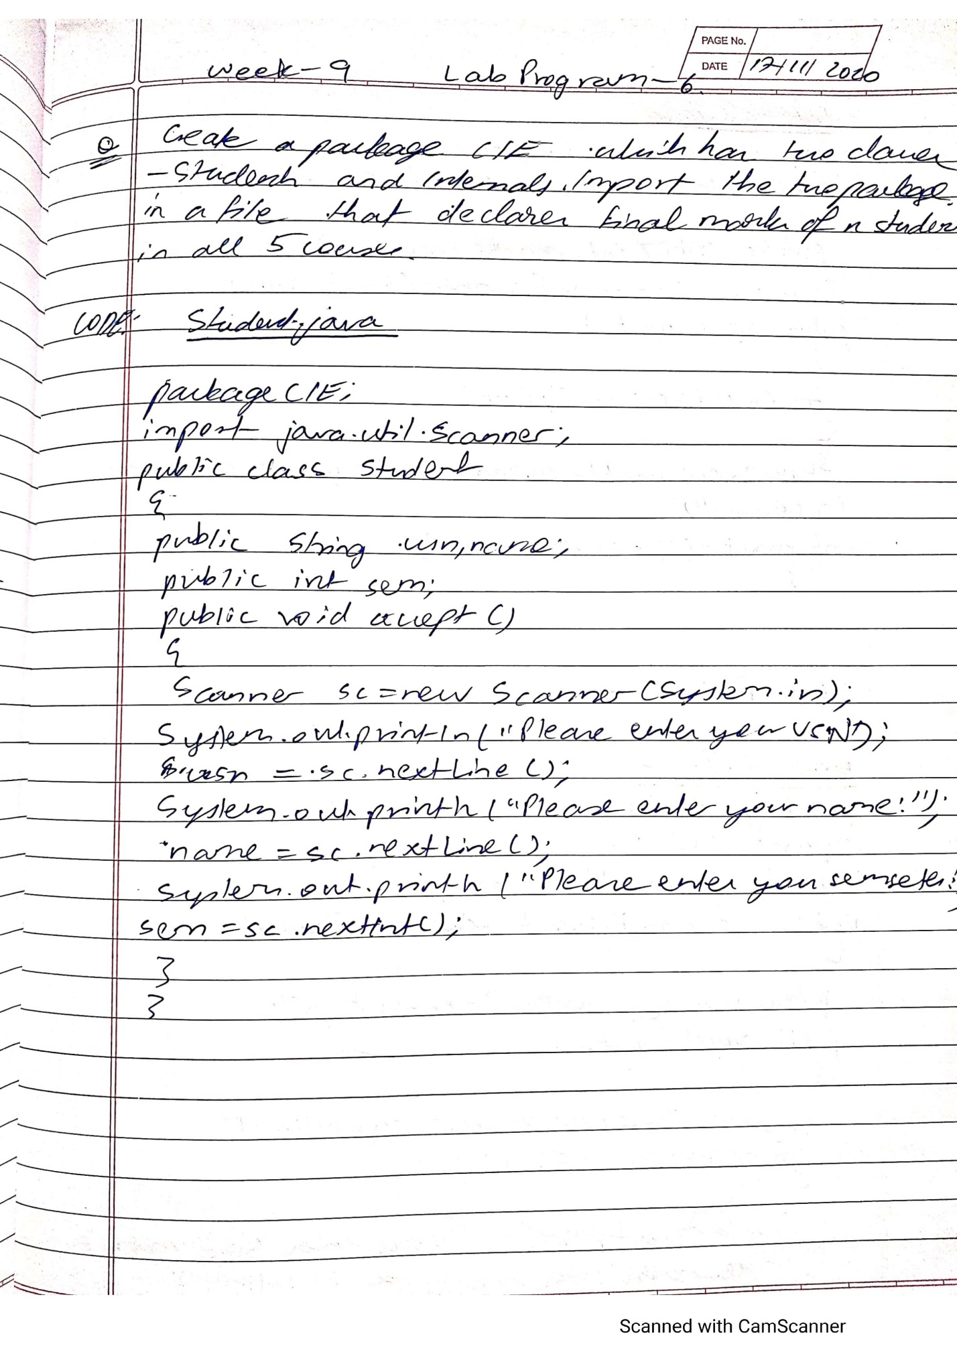

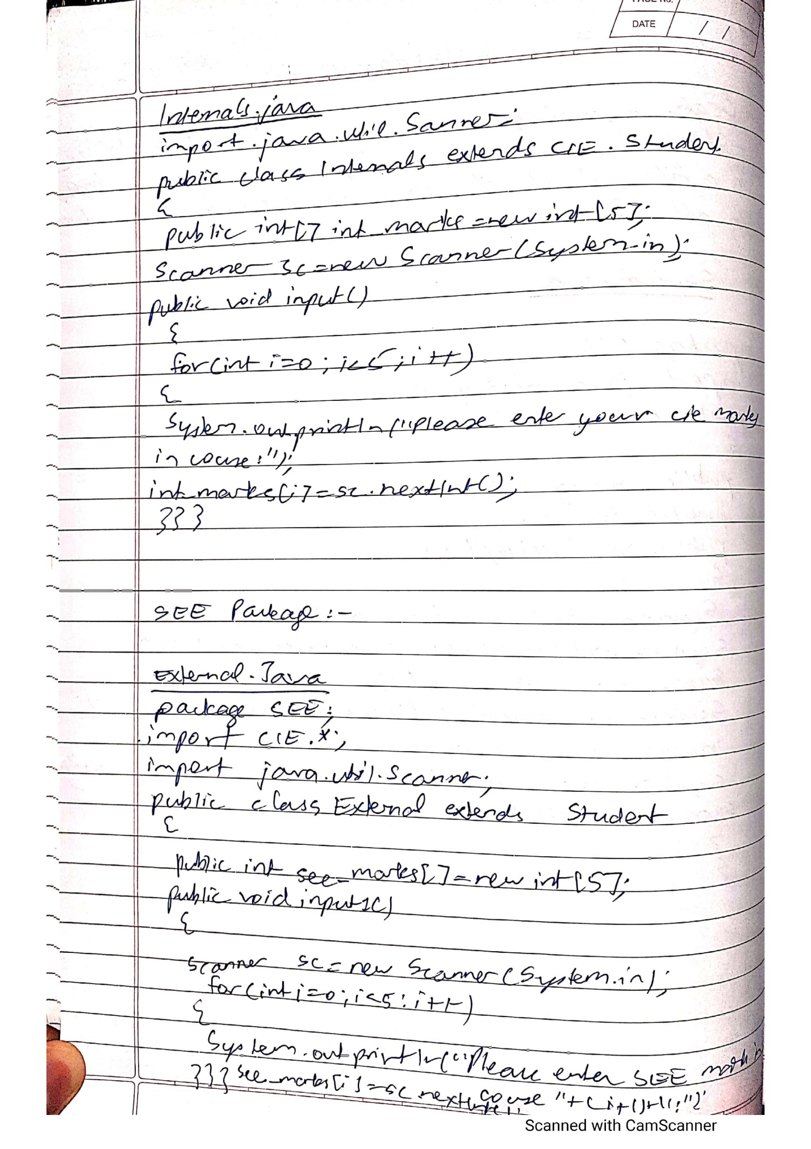

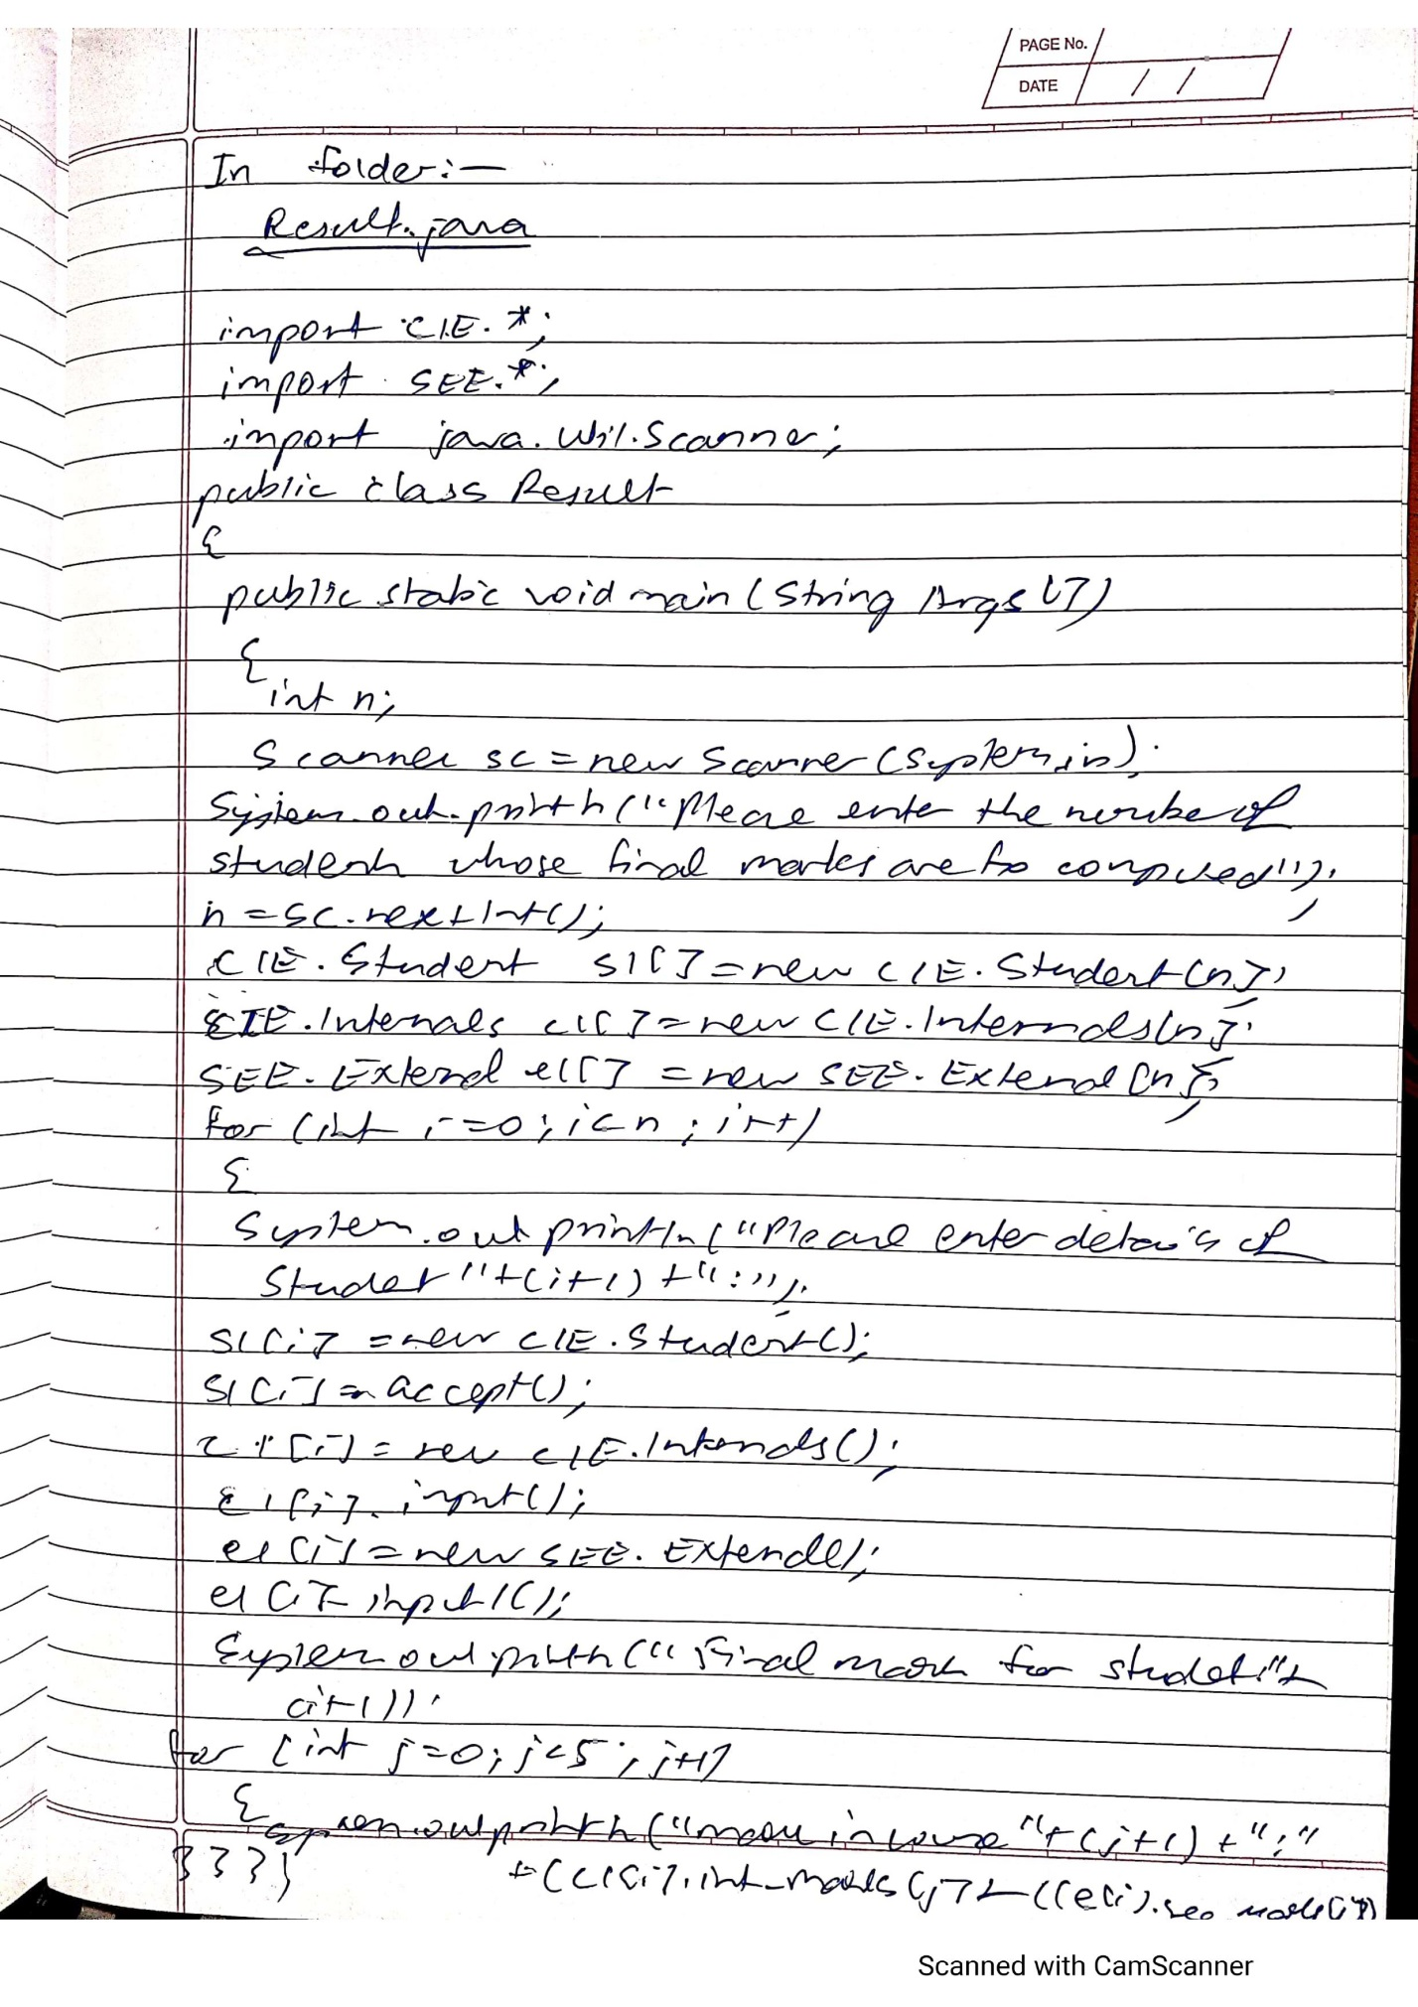

OUTPUT:

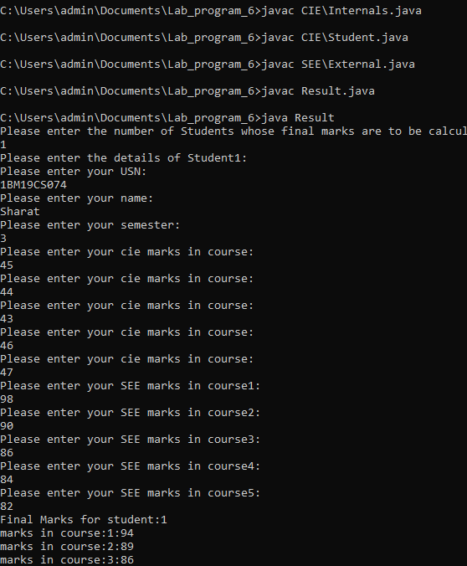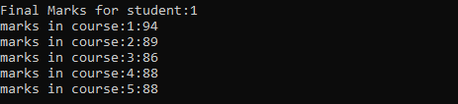

7) C:\Users\admin\Documents\LabProgram7_ss.PNG

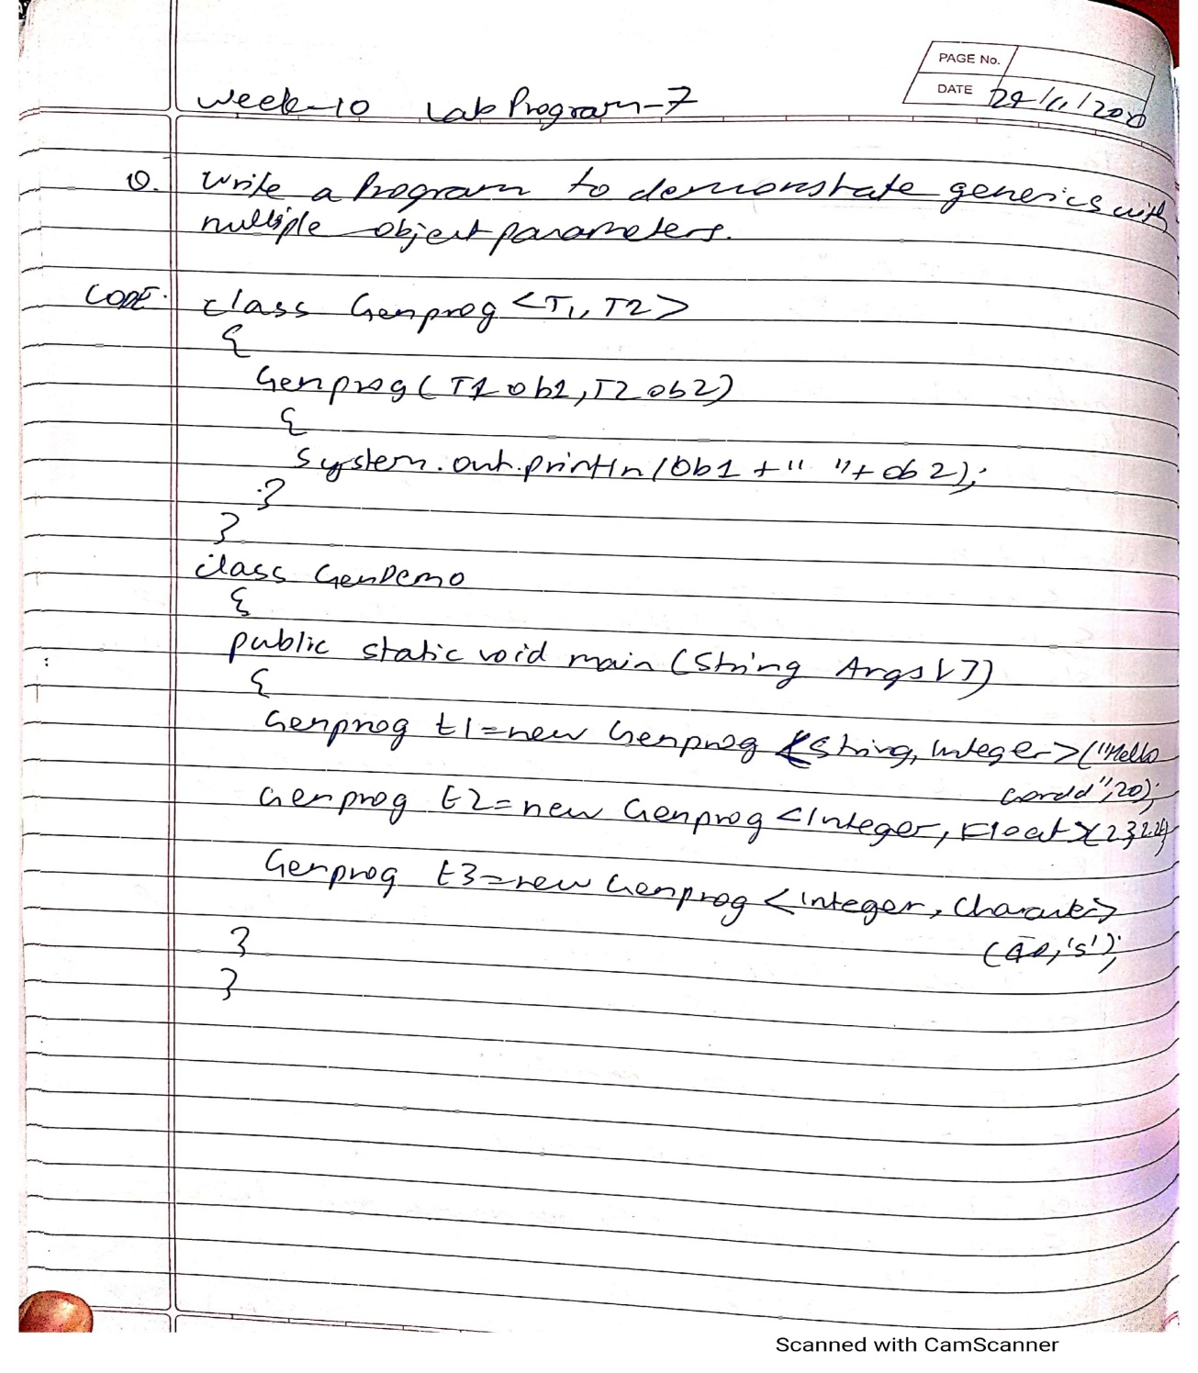

OUTPUT:

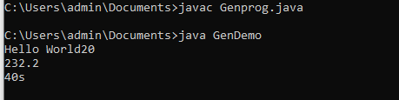

8) 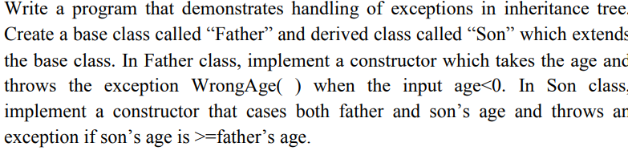

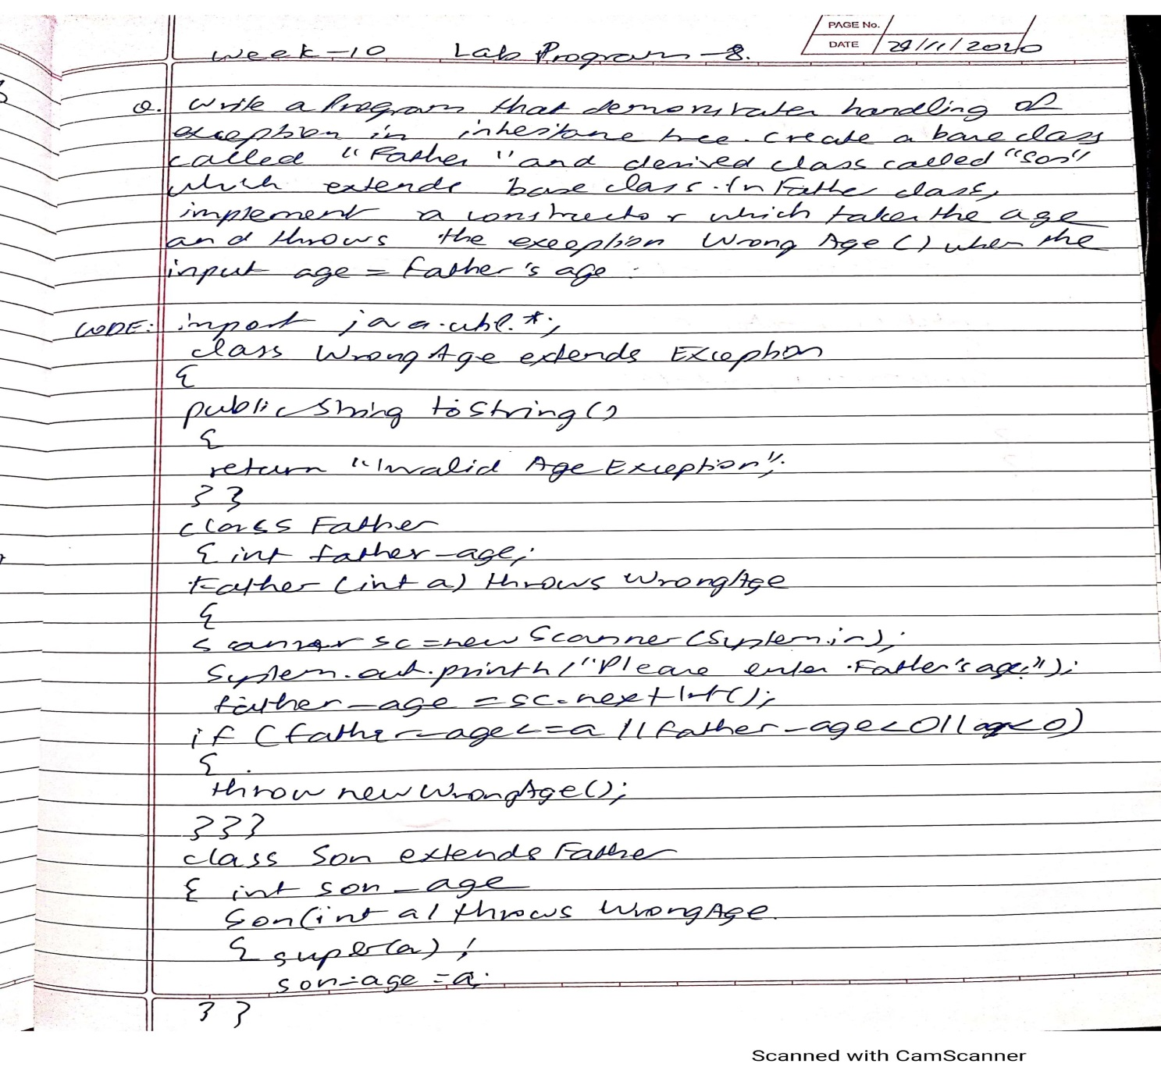

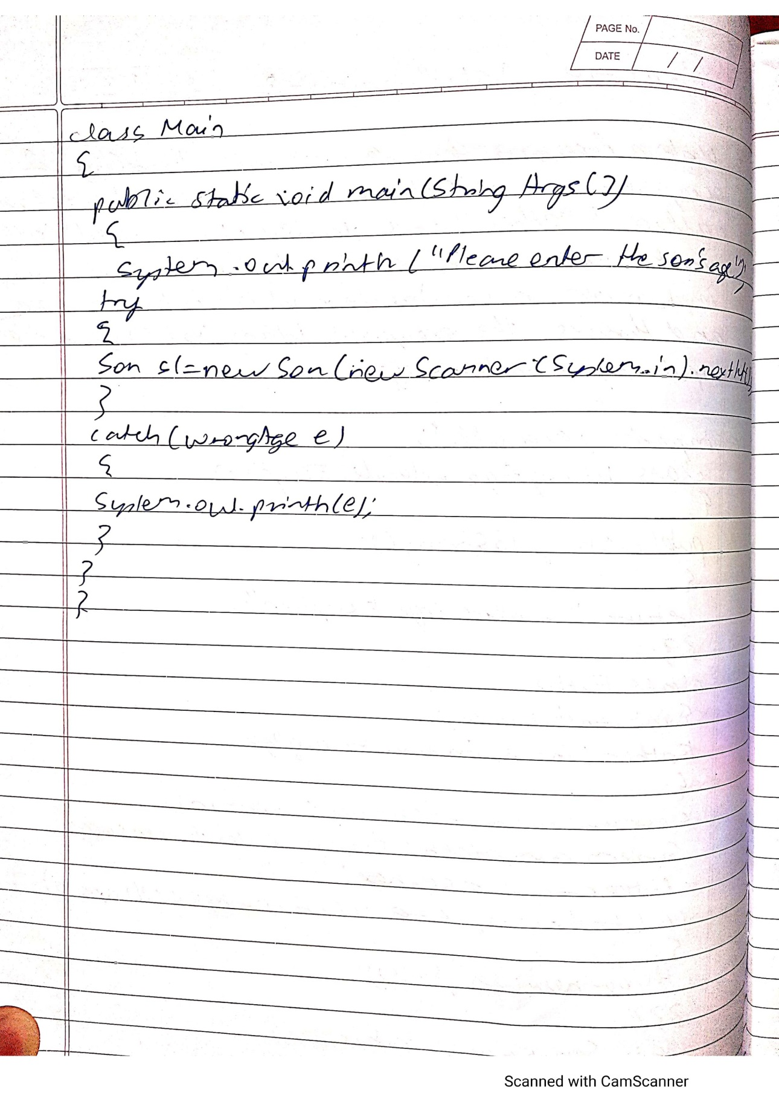

OUTPUT:

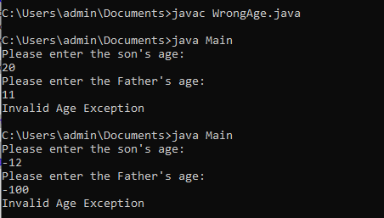

9) 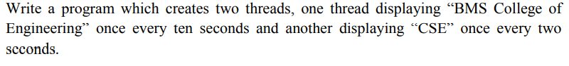

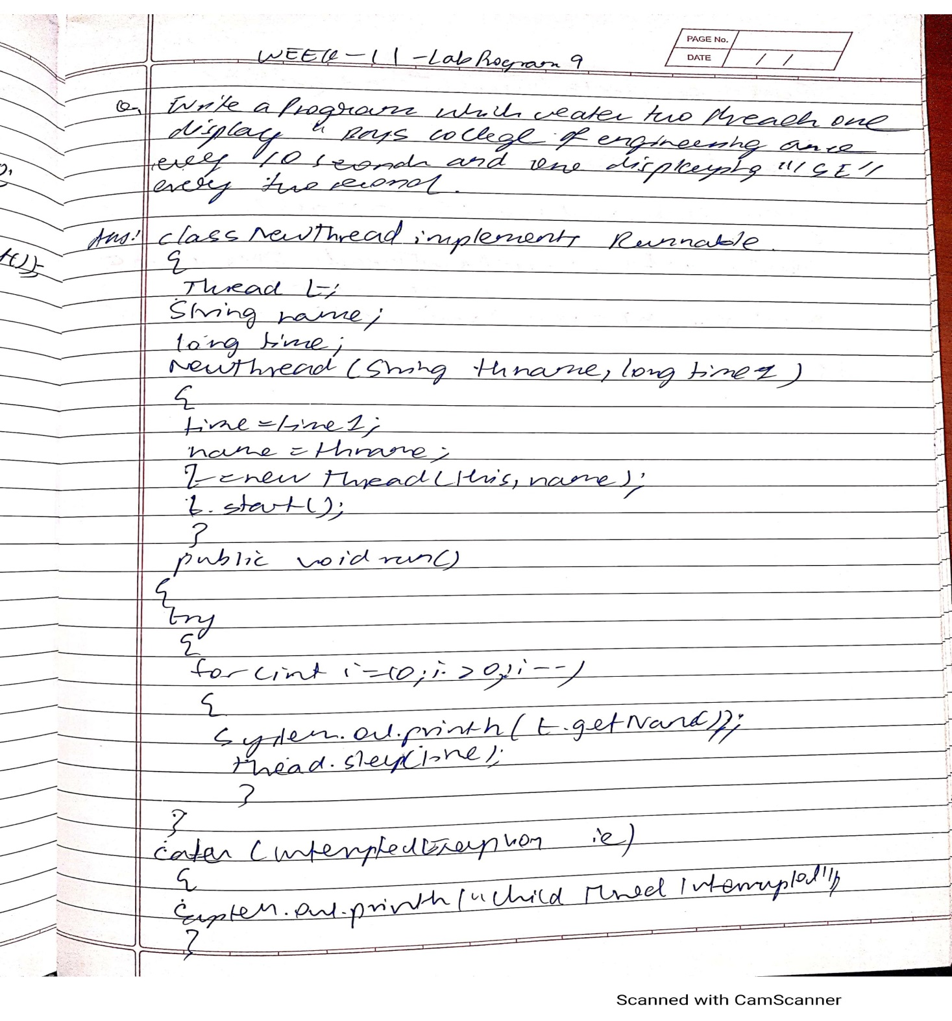

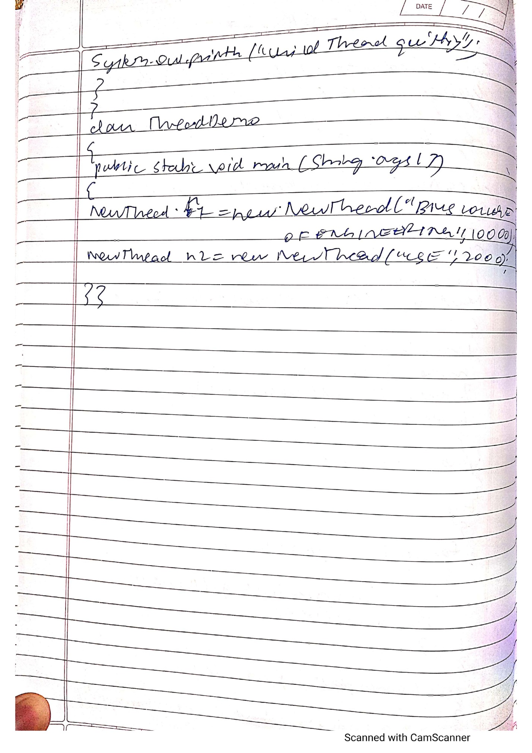

OUTPUT:

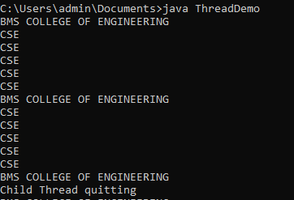

10) 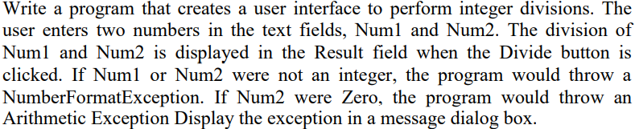

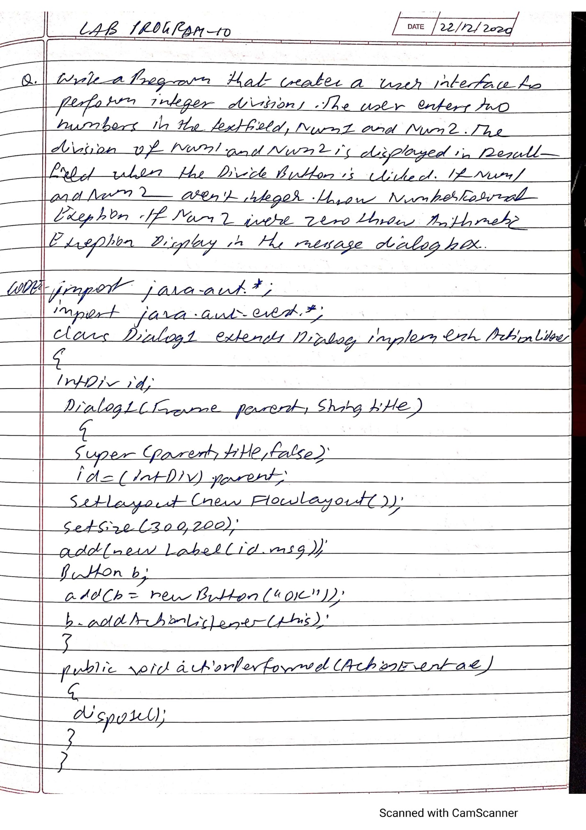

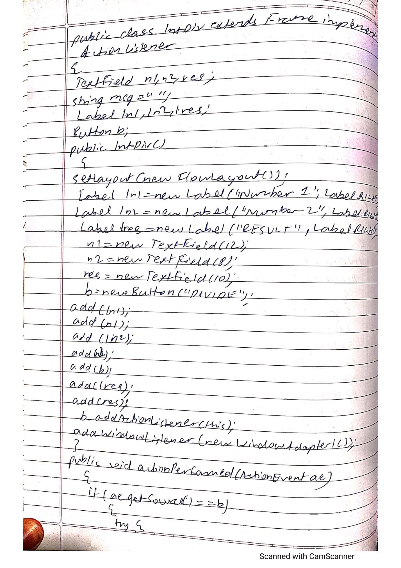

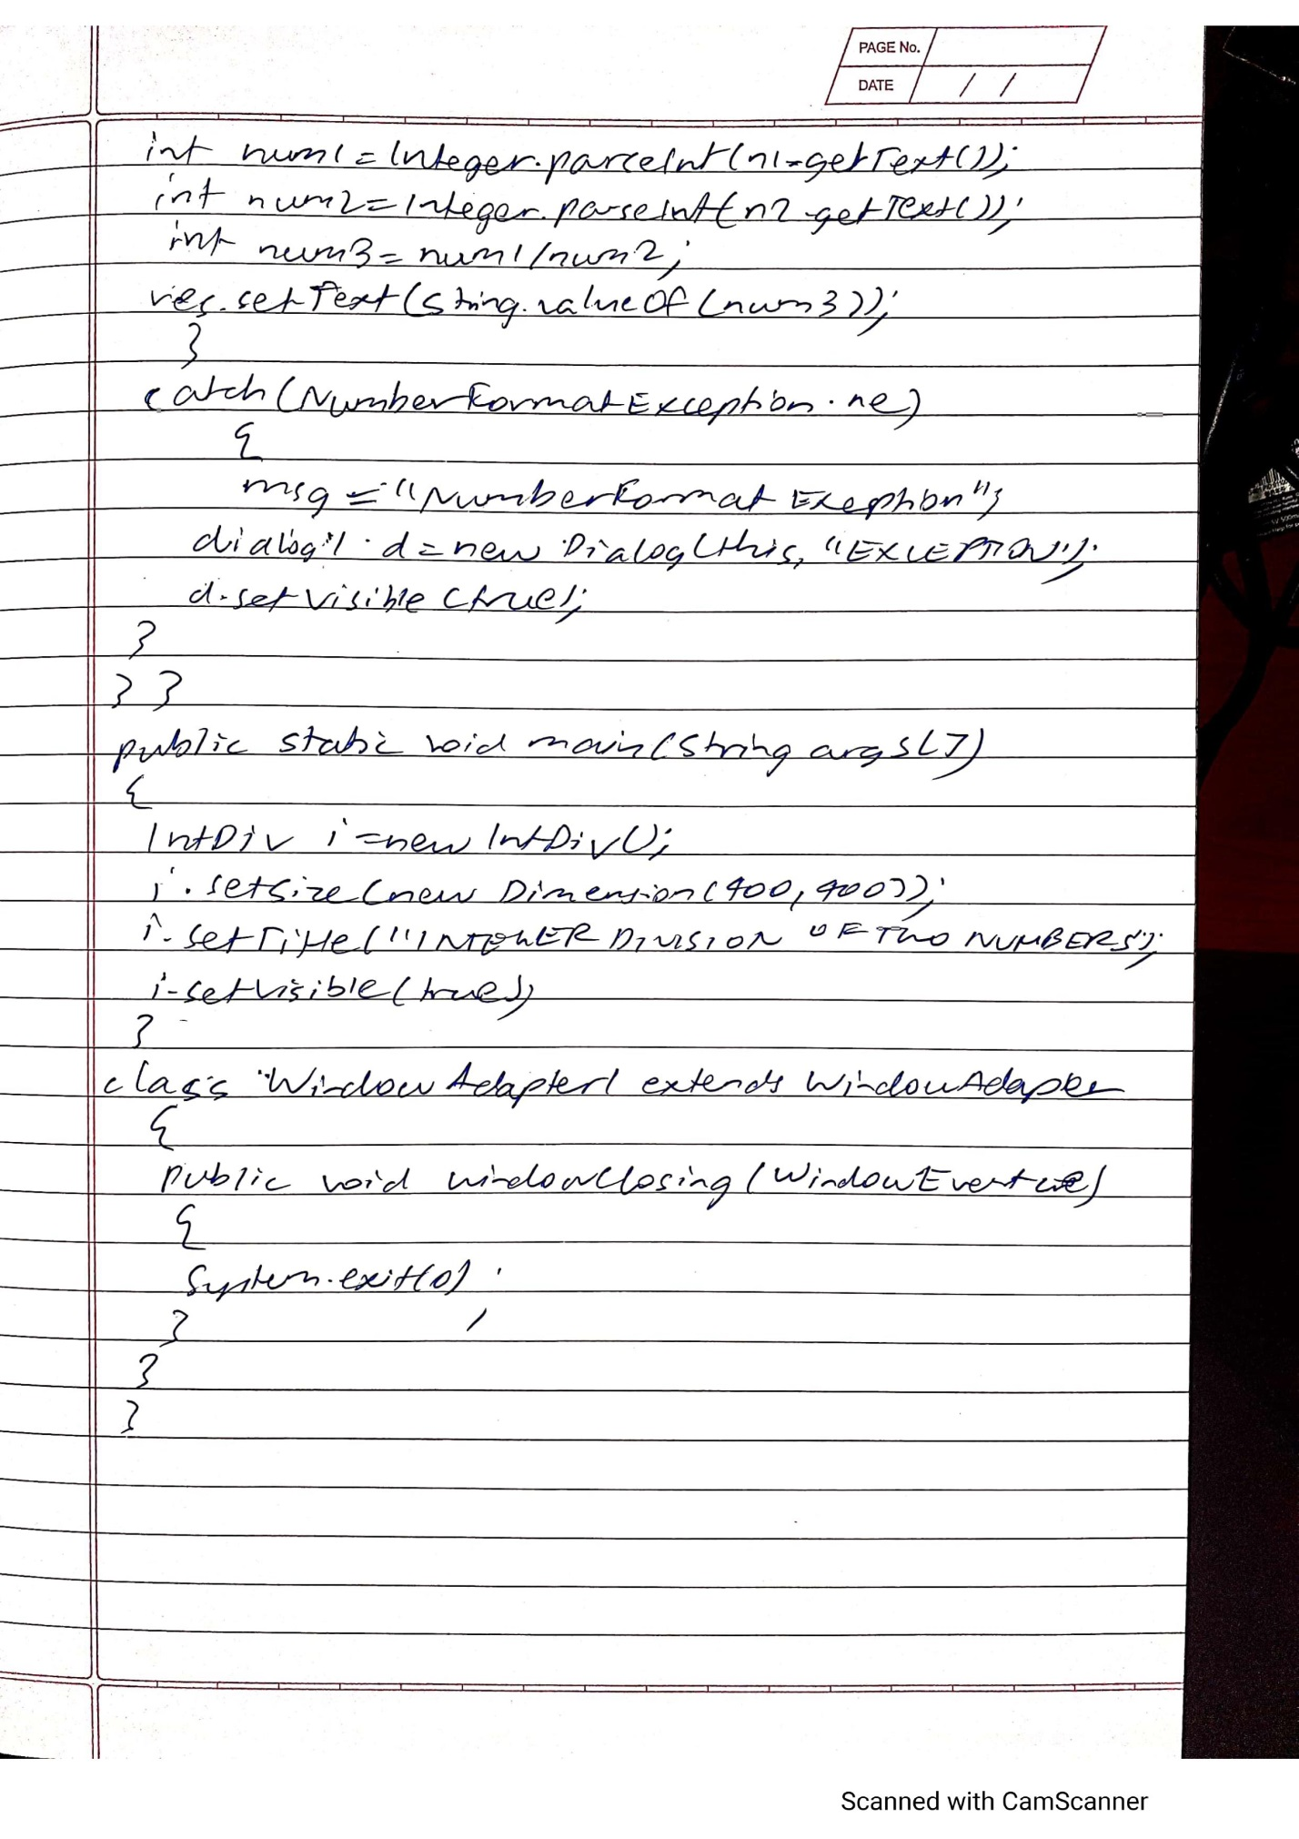

OUTPUT:

* 1. **Normal result**

C:\Users\admin\Documents\result_dialog_ss.PNG

* 1. **Arithmetic Exception**

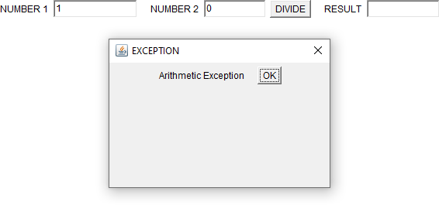

* 1. **NumberFormat Exception**

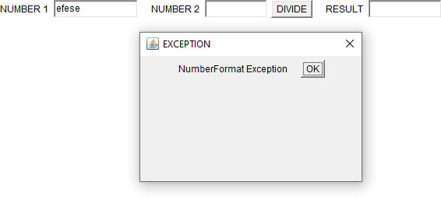

RECORD ENDS